**Ola Ride Insights**

Documented By: Gowtham

**Overview**

This project analyses Ola ride data to uncover key insights about booking trends, ride cancellations, payment methods, and customer behaviour.

This project aims to explore, analyse, and visualize revenue information, customer and driver behaviour, ratings and cancellation reasons.

**Project Objectives**

* Analyse Ola ride information from the Excel sheet.
* Visualize ride information values based on Booking status
* Identify top-booking customer details
* Build an interactive dashboard to explore data dynamically
* Support strategic decision-making for stakeholders through insights

**Dataset Details**

* **Source**:
  + The data pulled from Ola data set from google driver
* **Format**:
  + The Data received in the Excel format and it has the following field records.

**Data Columns**

* + 1. Date
  + 2. Time
  + 3. Booking_ID
  + 4. Booking_Status
  + 5. Customer_ID
  + 6. Vehicle_Type
  + 7. Pickup_Location
  + 8. Drop_Location
  + 9. V_TAT
  + 10. C_TAT
  + 11. cancelled_Rides_by_Customer
  + 12. cancelled_Rides_by_Driver
  + 13. Incomplete_Rides
  + 14. Incomplete_Rides_Reason
  + 15. Booking_Value
  + 16. Payment_Method
  + 17. Ride_Distance
  + 18. Driver_Ratings
  + 19. Customer_Rating
* **Insights**: Booking value, Payment method, Driver and Customer cancellation reason, ride distance and vehicle Type wise data creation.

**Technology Used**

* **Language**: Python
* **Libraries**:
  + Data Processing: Pandas, NumPy
  + Visualization: Matplotlib, Seaborn
* **Frontend**: Streamlit and PowerBI Dashboard

**ETL Process Flow**

* Read the CSV file using the pandas and load the data in to the data frame
* Validate the column information
* Converting the respective field in the proper data type
* Check null values
* Fill the null values data with proper data
* Validate the duplicates
* Validate the SQL environment variables
* Check the SQL connection
* Load the finalized data frame data MySQL

**Features & Visualizations**

**Streamlit**

* Booking Information, Success Booking Information & Status wise Booking status
* Average Booking rides, Top 5 customer details based on rides
* Minimum, Maximum and average rating provide by customer and driver.
* Driver cancellation, customer cancellation reason and data display in the bar chart based on values, Cancelled ride count by customer and driver and incomplete ride information.
* Total booking value, payment method wise booking values split up, Top 5 Customer details based on booking values.

**PowerBI**

* **Overall**

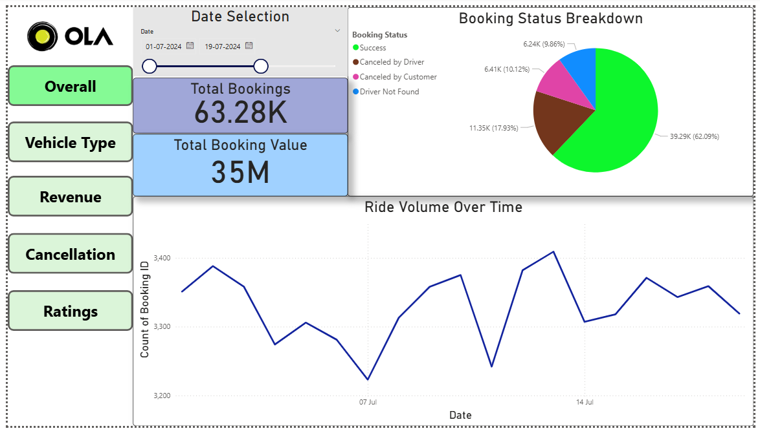

* **Vehicle Type**

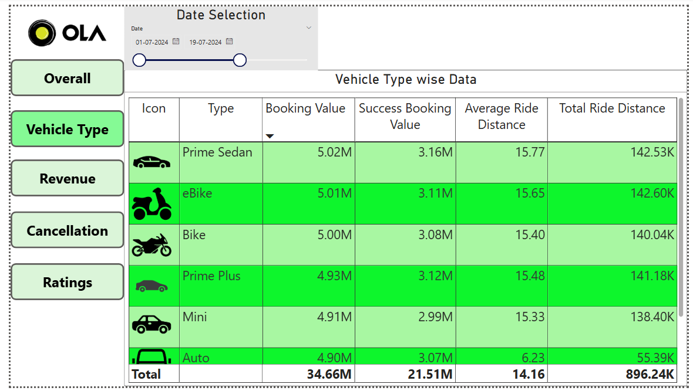

* **Revenue**

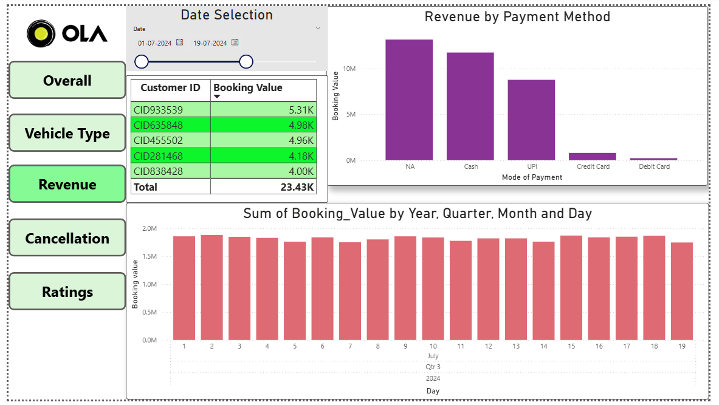

* **Cancellation**

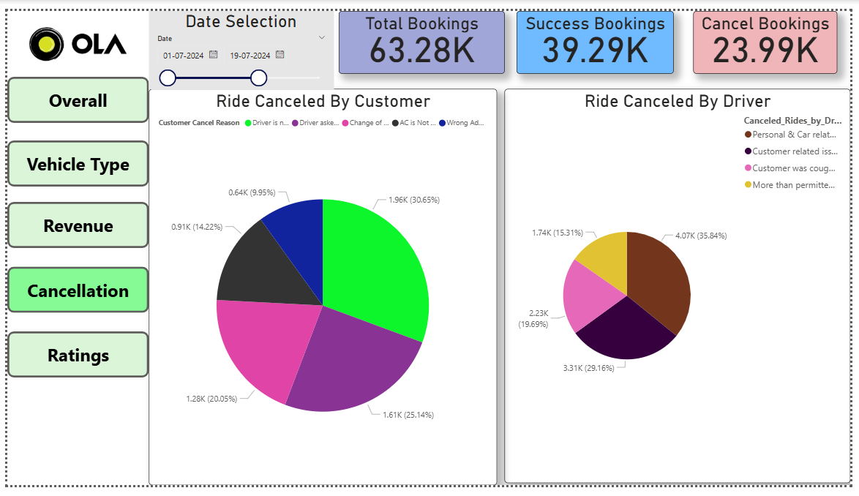

* **Rating**

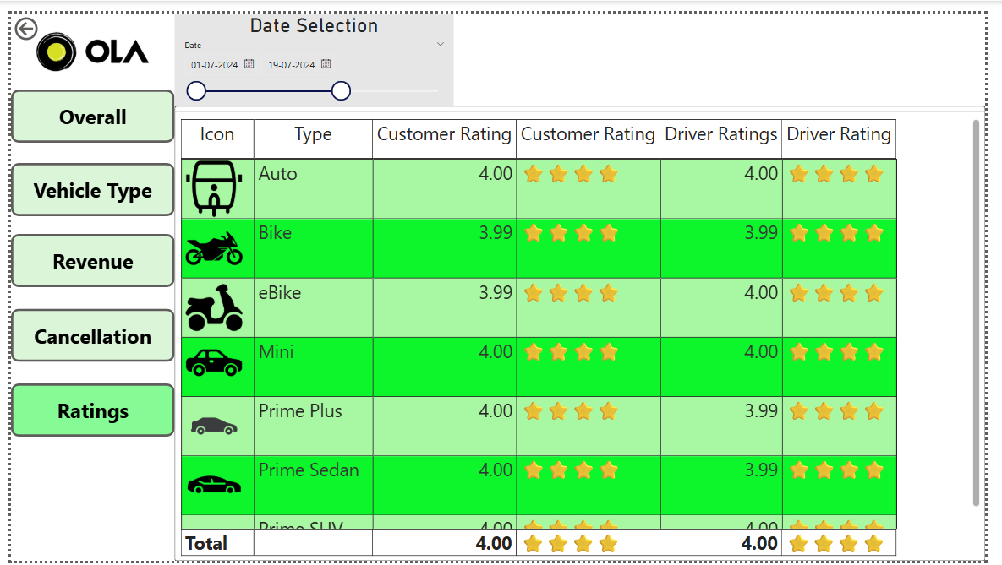

**Key Insights**

* Successful booking information
* Ride cancellation Reason by driver and customers
* Top 5 Customer based on frequently booking and Booking value
* Understand the preferred payment modes.
* Customer and Driver rating information
* The project successfully launched in render website
* https://olaride-insight.onrender.com/

**Conclusion**

This project provides a comprehensive view of ola rider behaviour base on the ola ride dataset. It enables users to explore trends interactively and supports data-driven decision-making for fintech businesses,drivers and customers.